Ministry of God
Student’s Name
Institution
Date

Ministry of God
An apostolic skill that involves writing the word of God is significant in making sure ministry is expanded and administered to many people in society. The act of writing about the information that teaches people about God has led to the spread of the gospel. Most people in different parts of the world can access the word of God effectively (Bracht, 2017). Preaching and teaching are apostolic skills that promote the spread of the word of God. According to Katharina Bracht, apostolic skills are essential in spreading the name of Christ in most parts of the world.
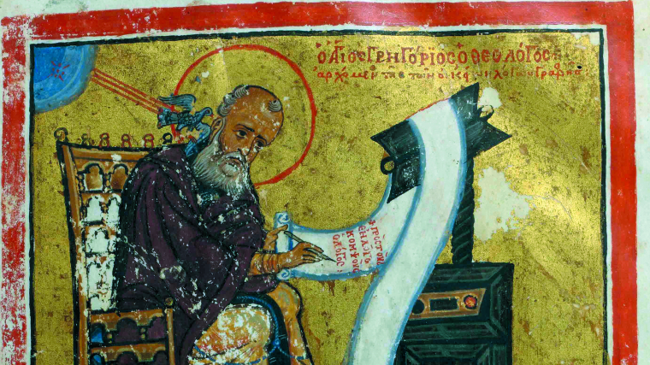
Apostolic Writing

According to Kent Wilson, the Christian leadership alliance makes stewardship leadership unique in many ways. Firstly, stewardship leadership creates a sense of identity where the leader views himself or herself to create understanding. Also, the steward leaders can develop an intimate relationship with God (Wilson, 2016). The steward leader becomes unique through the development of a strong relationship with God to assist in decision-making processes. Additionally, accountability gets developed by steward leaders through ensuring resources get managed. Management of resources and talent can get performed systematically. A sensible communication process that allows humility to get promoted amongst people is essential.
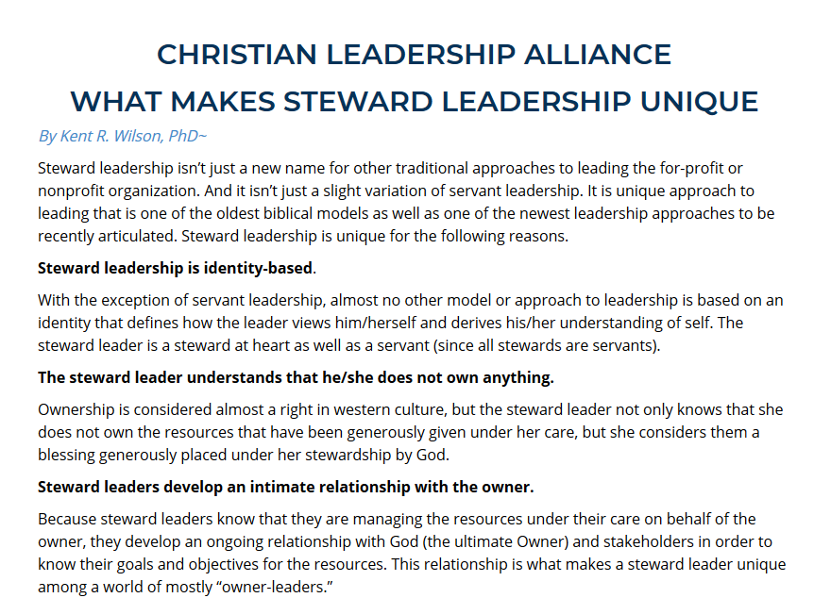
Kent Wilson

References
Bracht, K. (2017). Christ as Helmsman of the State Ship Old-church Daniel Reception and reformist Mastery of Understanding. ZEITSCHRIFT FUR KIRCHENGESCHICHTE, 128(1), 17-40.
Wilson, K. R. (2016). Steward leadership in the nonprofit organization. InterVarsity Press.

